Copy/Edit file from windows to Linux Remote machine

Install winscp

<https://winscp.net/eng/download.php>

Run Application and login

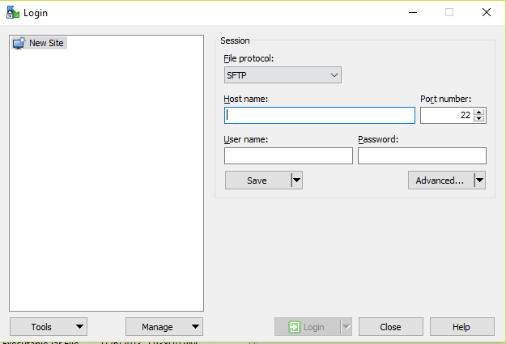

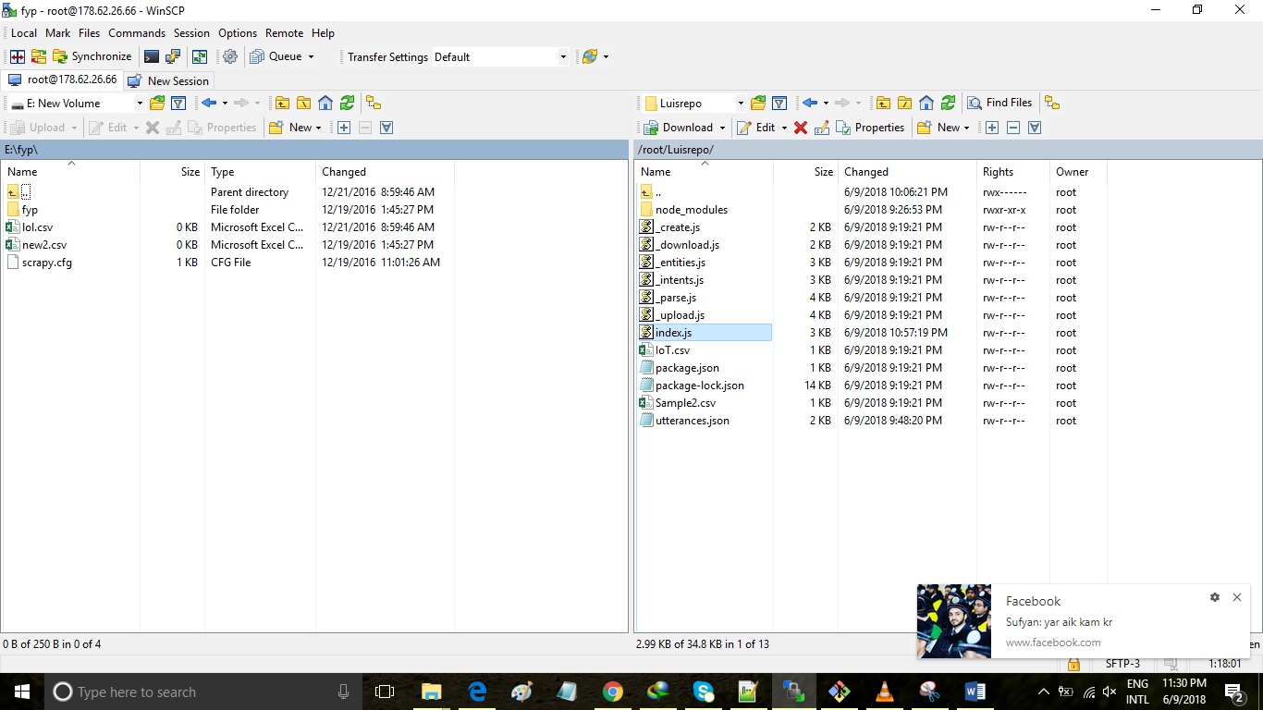

Figure : RIght Click to edit file